Deep Features for Image Retrieval

Summary / Observations:
Fitting a Gaussian mixture model for image data and cluster the same type of images.
Tasks:
- Applied the implementation of the EM [Expectation Maximization] algorithm, to cluster some more interesting data. In particular, we have a set of images that come from four categories: sunsets, rivers, trees and forests, and cloudy skies. For each image we are given the average intensity of its red, green, and blue pixels, so we have a 3-dimensional representation of our data. Our goal is to find a good clustering of these images using our EM implementation; ideally our algorithm would find clusters that roughly correspond to the four image categories.
- Explored clustering results and interpret the output of the EM algorithm
- Like k-means, EM is prone to converging to a local optimum. In practice, you may want to run EM multiple times with different random initialization.
- Observations: The results looked pretty good! Our algorithm seems to have done a good job overall at 'discovering' the four categories that from which our image data was drawn. It seems to have had the most difficulty in distinguishing between rivers and cloudy skies, probably due to the similar colour profiles of images in these categories; if we wanted to achieve better performance on distinguishing between these categories, we might need a richer representation of our data than simply the average [R G B] values for each image.
Visualizations:
We'll apply EM algorithm to cluster some more interesting data. In particular, we have a set of images that come from four categories: sunsets, rivers, trees and forests, and cloudy skies. For each image we are given the average intensity of its red, green, and blue pixels, so we have a 3-dimensional representation of our data. Our goal is to find a good clustering of these images using our EM implementation; ideally our algorithm would find clusters that roughly correspond to the four image categories.
The following sections will evaluate the results by asking the following questions:
- Convergence: How did the log likelihood change across iterations? Did the algorithm achieve convergence?
- Uncertainty: How did cluster assignment and uncertainty evolve?
- Interpretability: Can we view some example images from each cluster? Do these clusters correspond to known image categories?
Evaluating convergence:
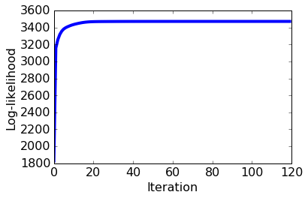
The log likelihood increases so quickly on the first few iterations that we can barely see the plotted line. Let's plot the log likelihood after the first three iterations to get a clearer view of what's going on:
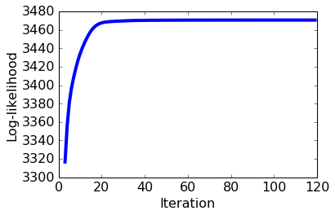
Evaluating Uncertainty:
To begin, we will visualize what happens when each data has random responsibilities.

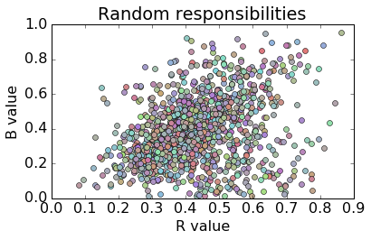
We now use the above plotting function to visualize the responsibilities after 1 iteration.

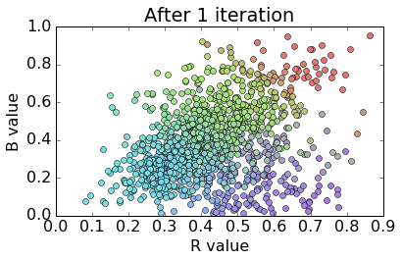
We now use the above plotting function to visualize the responsibilites after 20 iterations. We will see there are fewer unique colors; this indicates that there is more certainty that each point belongs to one of the four components in the model.

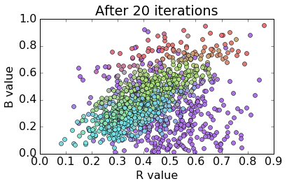

Plotting the responsibilities over time in [R B] space shows a meaningful change in cluster assignments over the course of the algorithm's execution. While the clusters look significantly better organized at the end of the algorithm than they did at the start, it appears from our plot that they are still not very well separated. We note that this is due in part our decision to plot 3D data in a 2D space; everything that was separated along the G axis is now "squashed" down onto the flat [R B] plane. If we were to plot the data in full [R G B] space, then we would expect to see further separation of the final clusters. We'll explore the cluster interpretability more in the next section.

Interpreting each cluster:
Let's dig into the clusters obtained from our EM implementation. Recall that our goal in this section is to cluster images based on their RGB values. We can evaluate the quality of our clustering by taking a look at a few images that 'belong' to each cluster. We hope to find that the clusters discovered by our EM algorithm correspond to different image categories - in this case, we know that our images came from four categories ('cloudy sky', 'rivers', 'sunsets', and 'trees and forests'), so we would expect to find that each component of our fitted mixture model roughly corresponds to one of these categories.

All Clouds in one Cluster:

[gallery ids="139,140,141,142,143" type="columns"]

All Rivers in one Cluster:

[gallery ids="144,145,146,147,148" type="columns"]

All trees in one Cluster:

[gallery ids="149,150,151,152,153" type="columns"]

All sunsets in one cluster

[gallery ids="154,155,156,157,158" type="columns"]
These look pretty good! Our algorithm seems to have done a good job overall at 'discovering' the four categories that from which our image data was drawn. It seems to have had the most difficulty in distinguishing between rivers and cloudy skies, probably due to the similar color profiles of images in these categories; if we wanted to achieve better performance on distinguishing between these categories, we might need a richer representation of our data than simply the average [R G B] values for each image.

ASSIGNMENT4:

Implementing EM for Gaussian mixtures
In this assignment you will
- implement the EM algorithm for a Gaussian mixture model
- apply your implementation to cluster images
- explore clustering results and interpret the output of the EM algorithm
Write-up/Pseudo-Code:
In this section, you will implement the EM algorithm. We will take the following steps:
Provide a log likelihood function for this model.
Implement the EM algorithm.
Create some synthetic data.
Visualize the progress of the parameters during the course of running EM.
Visualize the convergence of the model.
Log likelihood
We provide a function to calculate log likelihood for mixture of Gaussians. The log likelihood quantifies the probability of observing a given set of data under a particular setting of the parameters in our model. We will use this to assess convergence of our EM algorithm; specifically, we will keep looping through EM update steps until the log like hood ceases to increase at a certain rate.
- Compute loglikelihood - loglikelihood(data, weights, means, covs):
""" Compute the loglikelihood of the data for a Gaussian mixture model with the given parameters. """

E-step: assign cluster responsibilities, given current parameters¶
  - The first step in the EM algorithm is to compute cluster responsibilities. Let rik denote the responsibility of cluster k for data point . Note that cluster responsibilities are fractional parts: Cluster responsibilities for a single data point i should sum to 1.
  - ri1+ri2+…+riK=1
  - To figure how much a cluster is responsible for a given data point, we compute the likelihood of the data point under the particular cluster assignment, multiplied by the weight of the cluster. For data point i and cluster k , this quantity is
  - rik∝πkN(xi|μk,Σk)
  - where N(xi|μk,Σk) is the Gaussian distribution for cluster k with mean μk and covariance Σk ).
  - We used ∝ because the quantity N(xi|μk,Σk) is not yet the responsibility we want. To ensure that all responsibilities over each data point add up to 1, we add the normalization constant in the denominator:
  - rik=πkN(xi|μk,Σk)∑Kk=1πkN(xi|μk,Σk).
  - Complete the following function that computes rik for all data points i and clusters k.
  - Drawing from a Gaussian distribution. SciPy provides a convenient function multivariate_normal.pdf that computes the likelihood of seeing a data point in a multivariate Gaussian distribution. The usage is
  - multivariate_normal.pdf([data point], mean=[mean vector], cov=[covariance matrix])
  - Write a function compute_responsibilities(data, weights, means, covariances)
    - Update resp matrix so that resp[i,k] is the responsibility of cluster k for data point i.
    - To compute likelihood of seeing data point i given cluster k, use multivariate_normal.pdf.
    - Add up responsibilities over each data point and normalize

M-step: Update parameters, given current cluster responsibilities¶
  - Once the cluster responsibilities are computed, we update the parameters (weights, means, and covariances) associated with the clusters.
  - Computing soft counts. Before updating the parameters, we first compute what is known as "soft counts". The soft count of a cluster is the sum of all cluster responsibilities for that cluster:
  - Nsoftk=r1k+r2k+…+rNk=∑i=1Nrik
  - where we loop over data points. Note that, unlike k-means, we must loop over every single data point in the dataset. This is because all clusters are represented in all data points, to a varying degree.
  - We provide the function for computing the soft counts- compute_soft_counts(resp):

- Updating weights. The cluster weights show us how much each cluster is represented over all data points. The weight of cluster k is given by the ratio of the soft count Nsoftk to the total number of data points N:
- π̂ k=NsoftkN
Notice that N is equal to the sum over the soft counts Nsoftk of all clusters.
Write a function - compute_weights(counts)
- Updating means. The mean of each cluster is set to the weighted average of all data points, weighted by the cluster responsibilities:
- μ̂ k=1Nsoftk∑i=1Nrikxi
Write a function - compute_means(data, resp, counts)

- Updating covariances. The covariance of each cluster is set to the weighted average of all outer products, weighted by the cluster responsibilities:
- Σ̂ k=1Nsoftk∑i=1Nrik(xi−μ̂ k)(xi−μ̂ k)T
The "outer product" in this context refers to the matrix product
- (xi−μ̂ k)(xi−μ̂ k)T.
Letting (xi−μ̂ k) to be d×1 column vector, this product is a d×d matrix. Taking the weighted average of all outer products gives us the covariance matrix, which is also d×d.
Write a function - compute_covariances(data, resp, counts, means):

- The EM algorithm
  - Make copies of initial parameters, which we will update during each iteration
  - Infer dimensions of dataset and the number of clusters
  - Initialize some useful variables
  - for it in range(maxiter):
  - E-step: compute responsibilities
  - M-step
  - # Compute the total responsibility assigned to each cluster, which will be useful when
  - # implementing M-steps below. In the lectures this is called N^{soft}
  - Update the weight for cluster k using the M-step update rule for the cluster weight, \hat{\pi}_k.
  - Update means for cluster k using the M-step update rule for the mean variables.
  - Update covariances for cluster k using the M-step update rule for covariance variables.
  - Compute the loglikelihood at this iteration
  - Check for convergence in log-likelihood and store- If so, break the loop.

- Testing the implementation on the simulated data
To help us develop and test our implementation, we will generate some observations from a mixture of Gaussians and then run our EM algorithm to discover the mixture components. We'll begin with a function to generate the data, and a quick plot to visualize its output for a 2-dimensional mixture of three Gaussians.

Note:
Now we'll fit a mixture of Gaussians to this data using our implementation of the EM algorithm. As with k-means, it is important to ask how we obtain an initial configuration of mixing weights and component parameters. In this simple case, we'll take three random points to be the initial cluster means, use the empirical covariance of the data to be the initial covariance in each cluster (a clear overestimate), and set the initial mixing weights to be uniform across clusters.

Note. Like k-means, EM is prone to converging to a local optimum. In practice, you may want to run EM multiple times with different random initialization. We have omitted multiple restarts to keep the assignment reasonably short. For the purpose of this assignment, we assign a particular random seed (seed=4) to ensure consistent results among the students.

- Fitting a Gaussian mixture model for image data
  - Now that we're confident in our implementation of the EM algorithm, we'll apply it to cluster some more interesting data. In particular, we have a set of images that come from four categories: sunsets, rivers, trees and forests, and cloudy skies. For each image we are given the average intensity of its red, green, and blue pixels, so we have a 3-dimensional representation of our data. Our goal is to find a good clustering of these images using our EM implementation; ideally our algorithm would find clusters that roughly correspond to the four image categories.
  - We need to come up with initial estimates for the mixture weights and component parameters. Let's take three images to be our initial cluster centers, and let's initialize the covariance matrix of each cluster to be diagonal with each element equal to the sample variance from the full data. As in our test on simulated data, we'll start by assuming each mixture component has equal weight.

  - Evaluating convergence
    - Let's start by plotting the log likelihood at each iteration - we know that the EM algorithm guarantees that the log likelihood can only increase (or stay the same) after each iteration, so if our implementation is correct then we should see an increasing function.

Evaluating uncertainty¶
    - Next we'll explore the evolution of cluster assignment and uncertainty. Remember that the EM algorithm represents uncertainty about the cluster assignment of each data point through the responsibility matrix. Rather than making a 'hard' assignment of each data point to a single cluster, the algorithm computes the responsibility of each cluster for each data point, where the responsibility corresponds to our certainty that the observation came from that cluster.
    - We can track the evolution of the responsibilities across iterations to see how these 'soft' cluster assignments change as the algorithm fits the Gaussian mixture model to the data; one good way to do this is to plot the data and color each point according to its cluster responsibilities. Our data are three-dimensional, which can make visualization difficult, so to make things easier we will plot the data using only two dimensions, taking just the [R G], [G B] or [R B] values instead of the full [R G B] measurement for each observation.
    - Interpreting each cluster
    - Let's dig into the clusters obtained from our EM implementation. Recall that our goal in this section is to cluster images based on their RGB values. We can evaluate the quality of our clustering by taking a look at a few images that 'belong' to each cluster. We hope to find that the clusters discovered by our EM algorithm correspond to different image categories - in this case, we know that our images came from four categories ('cloudy sky', 'rivers', 'sunsets', and 'trees and forests'), so we would expect to find that each component of our fitted mixture model roughly corresponds to one of these categories.
    - If we want to examine some example images from each cluster, we first need to consider how we can determine cluster assignments of the images from our algorithm output. This was easy with k-means - every data point had a 'hard' assignment to a single cluster, and all we had to do was find the cluster center closest to the data point of interest. Here, our clusters are described by probability distributions (specifically, Gaussians) rather than single points, and our model maintains some uncertainty about the cluster assignment of each observation.
    - One way to phrase the question of cluster assignment for mixture models is as follows: how do we calculate the distance of a point from a distribution? Note that simple Euclidean distance might not be appropriate since (non-scaled) Euclidean distance doesn't take direction into account. For example, if a Gaussian mixture component is very stretched in one direction but narrow in another, then a data point one unit away along the 'stretched' dimension has much higher probability (and so would be thought of as closer) than a data point one unit away along the 'narrow' dimension.
    - In fact, the correct distance metric to use in this case is known as Mahalanobis distance. For a Gaussian distribution, this distance is proportional to the square root of the negative log likelihood. This makes sense intuitively - reducing the Mahalanobis distance of an observation from a cluster is equivalent to increasing that observation's probability according to the Gaussian that is used to represent the cluster. This also means that we can find the cluster assignment of an observation by taking the Gaussian component for which that observation scores highest. We'll use this fact to find the top examples that are 'closest' to each cluster.

  - Findings: These look pretty good! Our algorithm seems to have done a good job overall at 'discovering' the four categories that from which our image data was drawn. It seems to have had the most difficulty in distinguishing between rivers and cloudy skies, probably due to the similar color profiles of images in these categories; if we wanted to achieve better performance on distinguishing between these categories, we might need a richer representation of our data than simply the average [R G B] values for each image.

